Name Nadib Rana
Id :213002247

1. Create a Triangle with the help of android graphics.
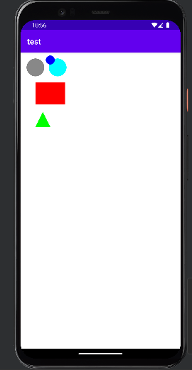
package com.example.test;
import android.content.Context;
import android.graphics.Canvas;
import android.graphics.Color;
import android.graphics.Paint;
import android.graphics.Path;
import android.os.Bundle;
import android.support.v7.app.AppCompatActivity;
import android.util.Log;
import android.view.View;
public class MainActivity extends AppCompatActivity {
DemoView dv;
@Override
protected void onCreate(Bundle savedInstanceState) {
super.onCreate(savedInstanceState);
Log.d("MainActivity", "onCreate() started");
// Initialize the custom view (DemoView)
dv = new DemoView(this);
// Check if the DemoView is initialized properly
if (dv != null) {
Log.d("MainActivity", "DemoView initialized successfully.");
} else {
Log.e("MainActivity", "DemoView initialization failed.");
}
// Set the custom view as the content of the activity
setContentView(dv);
Log.d("MainActivity", "setContentView() called successfully");
}
private class DemoView extends View {
public DemoView(Context context) {
super(context);
Log.d("DemoView", "DemoView constructor called");
}
@Override
protected void onDraw(Canvas canvas) {
super.onDraw(canvas);
Log.d("DemoView", "onDraw() called");
Paint ob = new Paint();
// Set the background color (white)
ob.setColor(Color.WHITE);
canvas.drawPaint(ob);
// Draw a gray circle
ob.setColor(Color.GRAY);
canvas.drawCircle(100, 100, 60, ob);
// Draw a cyan circle
ob.setColor(Color.CYAN);
canvas.drawCircle(250, 100, 60, ob);
// Draw a red rectangle
ob.setColor(Color.RED);
canvas.drawRect(100, 200, 300, 350, ob);
// Draw a new circle (color: blue)
ob.setColor(Color.BLUE);
canvas.drawCircle(200, 50, 30, ob);
// Create a Path to draw a triangle
Path path = new Path();
path.moveTo(150, 400);
path.lineTo(100, 500);
path.lineTo(200, 500);
path.close();
// Set the paint color for the triangle
ob.setColor(Color.GREEN);
// Draw the triangle on the canvas
canvas.drawPath(path, ob);
}
}
}

2.Create a Circle inside a Rectangle using graphical primitives.
CODE:
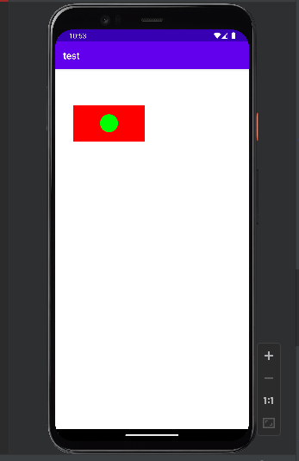
package com.example.test;
import android.content.Context;
import android.graphics.Canvas;
import android.graphics.Color;
import android.graphics.Paint;
import android.os.Bundle;
import android.support.v7.app.AppCompatActivity;
import android.util.Log;
import android.view.View;
public class MainActivity extends AppCompatActivity {
DemoView dv;
s
@Override
protected void onCreate(Bundle savedInstanceState) {
super.onCreate(savedInstanceState);
Log.d("MainActivity", "onCreate() started");
// Initialize the custom view (DemoView)
dv = new DemoView(this);
// Check if the DemoView is initialized properly
if (dv != null) {
Log.d("MainActivity", "DemoView initialized successfully.");
} else {
Log.e("MainActivity", "DemoView initialization failed.");
}
// Set the custom view as the content of the activity
setContentView(dv);
Log.d("MainActivity", "setContentView() called successfully");
}
private class DemoView extends View {
public DemoView(Context context) {
super(context);
Log.d("DemoView", "DemoView constructor called");
}
@Override
protected void onDraw(Canvas canvas) {
super.onDraw(canvas);
Log.d("DemoView", "onDraw() called");
Paint ob = new Paint();
// Set the background color (white)
ob.setColor(Color.WHITE);
canvas.drawPaint(ob);
// Draw a red rectangle (left, top, right, bottom)
ob.setColor(Color.RED);
canvas.drawRect(100, 200, 500, 400, ob);
// Calculate the center of the rectangle
float centerX = (100 + 500) / 2; // Horizontal center
float centerY = (200 + 400) / 2; // Vertical center
float radius = (400 - 200) / 4; // Half of the rectangle's height (for a smaller circle)
// Draw a blue circle inside the rectangle
ob.setColor(Color.GREEN);
canvas.drawCircle(centerX, centerY, radius, ob); // Circle inside the rectangle
}
}
}
OUTPUT:

3. Create a Rhombus using android graphical primitives.

Code:
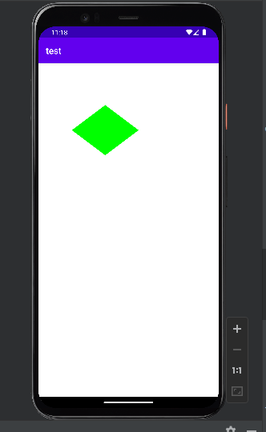
package com.example.test;
import android.content.Context;
import android.graphics.Canvas;
import android.graphics.Color;
import android.graphics.Paint;
import android.graphics.Path;
import android.os.Bundle;
import android.support.v7.app.AppCompatActivity;
import android.util.Log;
import android.view.View;
public class MainActivity extends AppCompatActivity {
DemoView dv;
@Override
protected void onCreate(Bundle savedInstanceState) {
super.onCreate(savedInstanceState);
Log.d("MainActivity", "onCreate() started");
// Initialize the custom view (DemoView)
dv = new DemoView(this);
// Check if the DemoView is initialized properly
if (dv != null) {
Log.d("MainActivity", "DemoView initialized successfully.");
} else {
Log.e("MainActivity", "DemoView initialization failed.");
}
// Set the custom view as the content of the activity
setContentView(dv);
Log.d("MainActivity", "setContentView() called successfully");
}
private class DemoView extends View {
public DemoView(Context context) {
super(context);
Log.d("DemoView", "DemoView constructor called");
}
@Override
protected void onDraw(Canvas canvas) {
super.onDraw(canvas);
Log.d("DemoView", "onDraw() called");
Paint ob = new Paint();
// Set the background color (white)
ob.setColor(Color.WHITE);
canvas.drawPaint(ob);
// Set up the paint for the rhombus
ob.setColor(Color.GREEN);
ob.setStyle(Paint.Style.FILL); // Fill the rhombus
// Define the vertices for the rhombus
float centerX = 400; // X-coordinate of the center
float centerY = 400; // Y-coordinate of the center
float width = 200; // Horizontal distance from center to left/right
float height = 150; // Vertical distance from center to top/bottom
// Create the path to draw the rhombus (diamond shape)
Path path = new Path();
path.moveTo(centerX, centerY - height); // Top vertex
path.lineTo(centerX - width, centerY); // Left vertex
path.lineTo(centerX, centerY + height); // Bottom vertex
path.lineTo(centerX + width, centerY); // Right vertex
path.close(); // Close the path to form the rhombus
// Draw the rhombus on the canvas
canvas.drawPath(path, ob);
}
}
}

